**Graphics and Animation Tools**

**LAB**

**Experiment – 3 Design of Google Logo using GIMP.**

**Step - 1:**

Open GIMP, go to file → new file → choose 1080x1080 size screen with white as background.

**Step - 2:**

Go to image → Guides → Guides by % → Choose 50% horizontal guide and in similar way 50% vertical guide.

**Step - 3:**

Now choose ellipse tool from select toolbar, and start drawing a circle in one of the quadrants of your choice. Press Ctrl + Shift to position it at the centre.

**Step - 4:**

Go to select → None.

**Step - 5:**

Go to path →Make the selection visible → Now, add it to the text.

**Step - 6:**

Right click on the text layer, choose text along path → go to path and add new layer with it.

**Step - 7:**

Go to path, text1 → Transparent, fill the path → solid colour → delete text1 path.

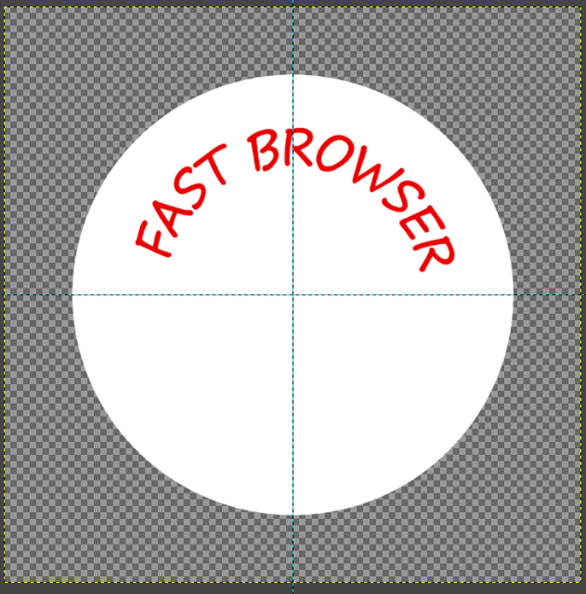

**Step - 8:**

Now text-2, click to toolbar → Flip tool → Transform row → Direction Flipping.

**Step - 9:**

Now go to the text layer → right click on text-2 → Click on text along path → Adjust the position of 2nd text by rotate tool.

**Step - 10:**

Add new layer from the 2nd text, select that layer → Go to the path → Right click on it, select text along path. Fill path with solid colour.

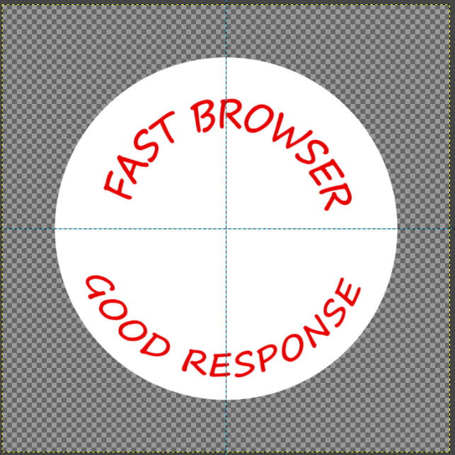

**Step - 11:**

Go to file and open the google logo as layer and place it in the centre and make other layers invisible.

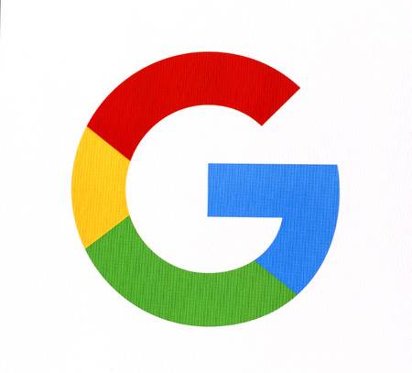

**Step - 12:**

Save the output. And export it in other location with (.xcf) extension.

